DIP Homework01

ECE 5273

Homework problem 1:

1. Obtain the images “lena.bin” and “peppers.bin” from the course web site. Each image

has 256 × 256 pixels and each pixel has 8 bits.

(a) Read and display the images.

(b) Define a new 256 × 256 image J as follows: the left half of J, e.g., the first 128

columns, should be equal to the left half of the Lena image. The right half of J,

e.g., the 129th column through the 256th column, should be equal to the right

half of the Peppers image.

(c) Define a new 256 × 256 image K by swapping the left and right halves of J.

(d) Be sure to turn in: A listing of your code and printouts of the original images,

image J, and image K.

Solution:

% to read lena.bin image

fidLena = fopen('lena.bin','r');

[Lena,junk] = fread(fidLena,[256,256],'uchar');

% to read peppers.bin image

fidpeppers = fopen('peppers.bin','r');

[peppers,junk] = fread(fidpeppers,[256,256],'uchar');

% to display lena image

Lena = Lena' ;% for trasnpose of the image

figure(1);colormap(gray(256));

image(Lena);

title('Original Lena Image');

% to display peppers image

peppers = peppers' ;% for transpose of the image

figure(2);colormap(gray(256));

image(peppers);

title('Original Peppers Image');

% defining new image J

J(1:256,1:128)=Lena(1:256,1:128);

J(1:256,129:256)=peppers(1:256,129:256);

figure(3);colormap(gray(256));

image(J);

title('Image J');

% defining new image K by swapping

K(1:256,1:128)=J(1:256,129:256);

K(1:256,129:256)=J(1:256,1:128);

figure(4);colormap(gray(256));

image(K);

title('Image K');

% to write lena image

print-dtiffM_Lena.tif; % write figure as tif

fidOut = fopen('Outfile.bin','w+');

LenaOut = Lena';

fwrite(fidOut,LenaOut,'uchar'); % write raw image data

fclose(fidLena);fclose(fidOut);

% to write peppers image

print-dtiffM_peppers.tif; % write figure as tif

fidOut = fopen('Outfile.bin','w+');

peppersOut = peppers';

fwrite(fidOut,peppersOut,'uchar'); % write raw image data

fclose(fidpeppers);fclose(fidOut);

Output Images: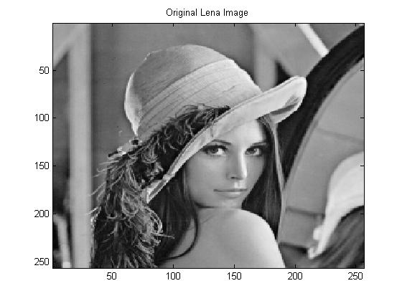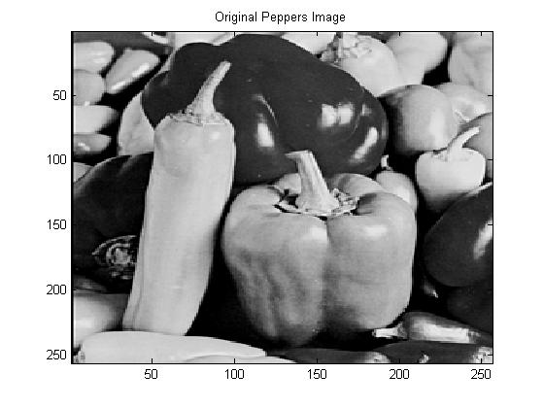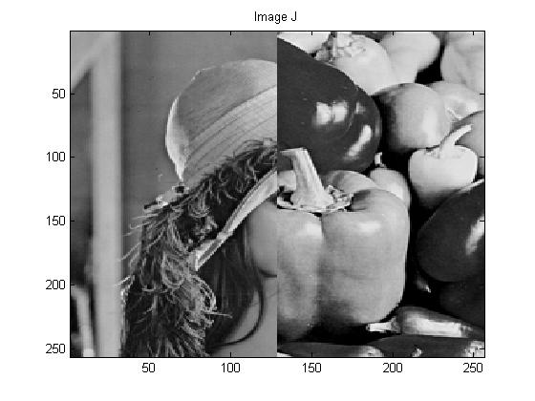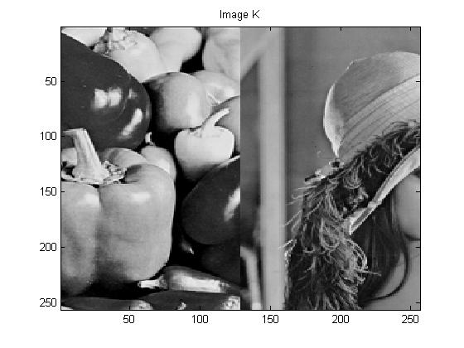

Homework problem 2:

2. Use Matlab for this problem.

(a) Type help imread and help imwrite at the Matlab prompt to read the online

help for these commands.

(b) Obtain the image “lenagray.jpg” from the course web site. It is the same image

that you used in the first problem, but the file is in JPEG format this time.

(c) Use the imread function to read in the image. Let’s call this image J1.

(d) Make a new image J2 that is the photographic negative of J1. To do this, set

J2 = 255−J1. Display the new image J2 and use the imwrite command to write

it out as a JPEG file.

(e) Be sure to turn in: A listing of your code and printouts of the original and

modified images.

Solution:

% using imread to call image J1

J1=imread('lenagray.jpg');

%display image J1

figure(1);

imshow(J1);

title('Image J1');

%display image J2

figure(2);

J2=255-J1;% condition to obtain photographic negative

imshow(J2);

title('Image J2');

% to write J2 as JPEG file

imwrite(J2,'lenaneg.jpg');

Output Images:

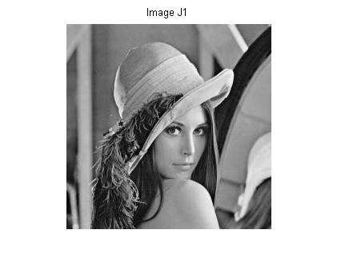

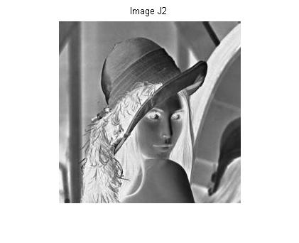

Homework Problem 3:

3. Use Matlab for this problem.

(a) Obtain the color image “lena512color.jpg” from the course web site. It is the

same image that you used in the first two problems, except this time it is in color

(each pixel has 24 bits) and the size is 512 × 512 pixels. If you read the image

into a Matlab array J1, then J1(:,:,1) is the Red band, J1(:,:,2) is the Green

band, and J1(:,:,3) is the Blue band. In each band, each pixel has 8 bits, just

like the image in the first problem.

(b) Use imread to read in the image and then display it. Let’s call this image J1.

(c) Make a new color image J2 by swapping the color bands of J1 as follows. First,

just set J2 = J1 to initialize the new image with the right size. Then make the

Red band of J2 equal to the Blue band of J1, make the Green band of J2 equal

to the Red band of J1, and make the Blue band of J2 equal to the Green band of

J1.

For example, to set the Red band of J2 equal to the Blue band of J1, you can

type J2(:,:,1) = J1(:,:,3);.

(d) Display the new image and use imwrite to write it out to a JPEG file.

(e) Be sure to turn in: A listing of your code and printouts of the original and

modified images.

Solution:

%to read JPEG file

J1=imread('lena512color.jpg');

%to display image J1

figure(1);

imshow(J1);

title('Color Image J1');

J2=J1;%condition for right size

J2(:,:,1)= J1(:,:,3);%Red band of J2= Blue band of J1

J2(:,:,2)= J1(:,:,1);%Green band of J2= Red band of J1

J2(:,:,3)= J1(:,:,2);%Blue band of J2= Green band of J1

%to display image J2

figure(2);

imshow(J2);

title('Different Bands of J1');

%to write it out as JPEG file

imwrite(J2,'BluebandJ1.jpg');

Output Images: